Detecting Trees using Image Deep Learning Analysis
By Eng: Mohammed AlQahtany
Geospatial Engineer

I would like to use Image analysis Deep Learning Techniques to detect the trees near Jefferson National Park, Virginia , USA .The Raster is uploaded from Esri for this area
This Technique cannot be achieved without getting the suitable model , for instance you need to download trees detection model before .

Deep Learning Detects the features I want inside the raster , in this case ( trees) without human interference with high accuracy and speed

Study Area:
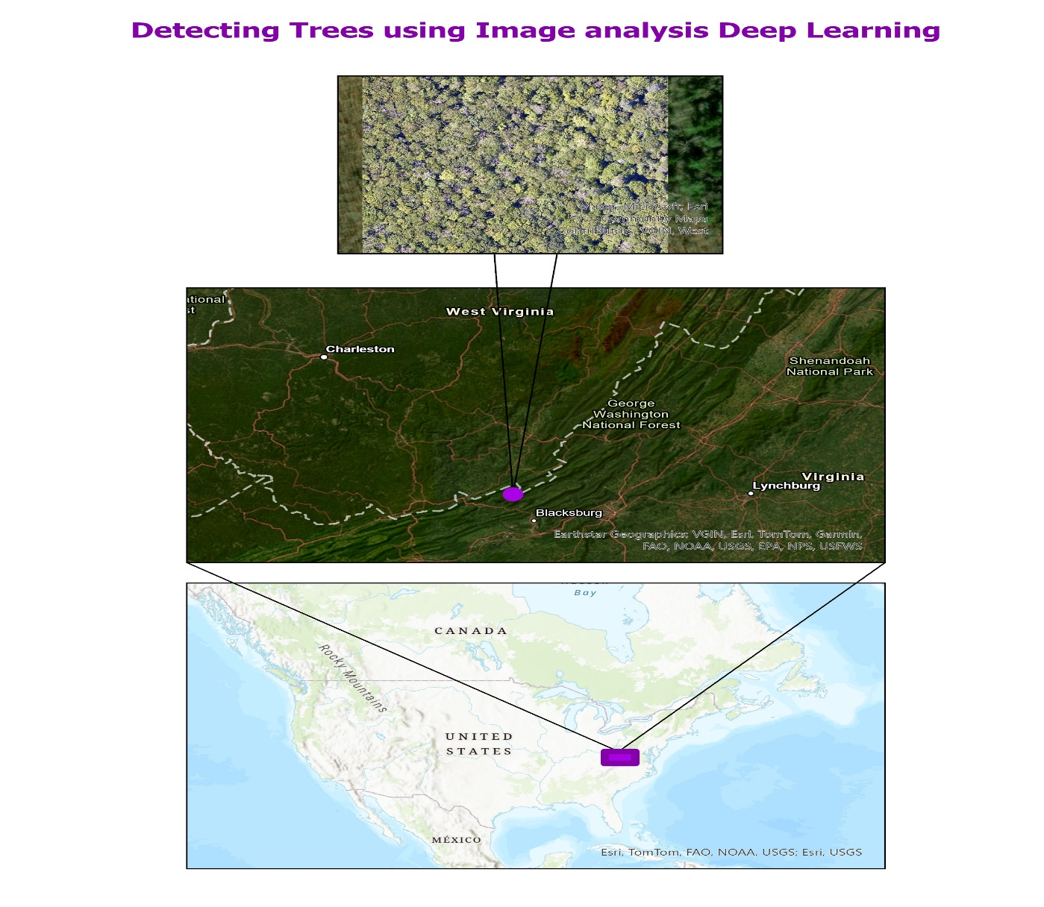

Now Let's See the forest After I apply Tree Detection Deep Learning:

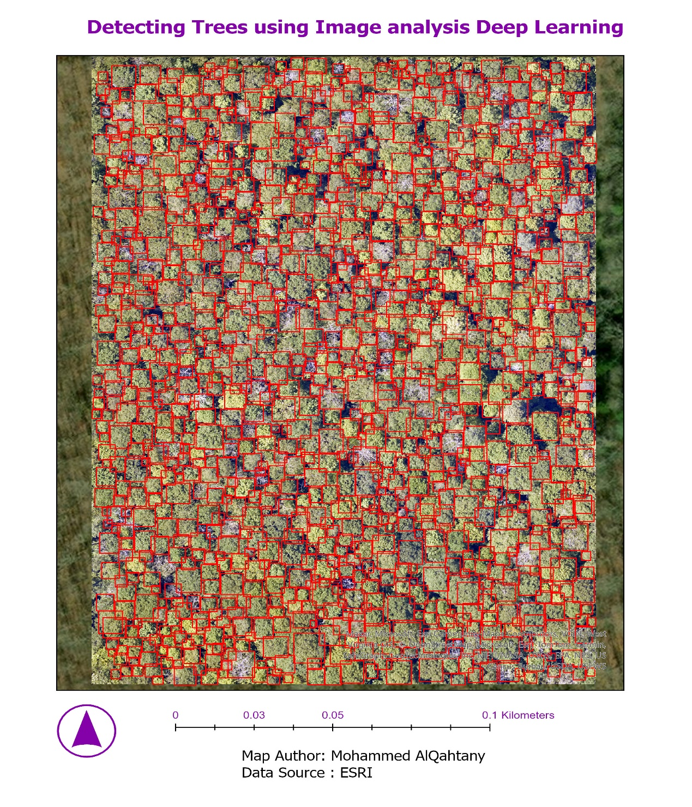
This Technique Can be applied in Various fields like Parcels Detection , Cars tracking , Water bodies detection , Buildings Detection etc. but requires High resolution raster from Drone or Airborn.

